Welcome  Please log in  Username  Email  Phone Number  Next | Welcome  Start Your Business Now  We facilitate the incorporation procedures of your start-up. You will get your hands on your company’s legal documents by completing the following steps.  All you have to do is to complete our simple track and to choose the company type you want.  It takes only a couple of minutes to incorporate online!
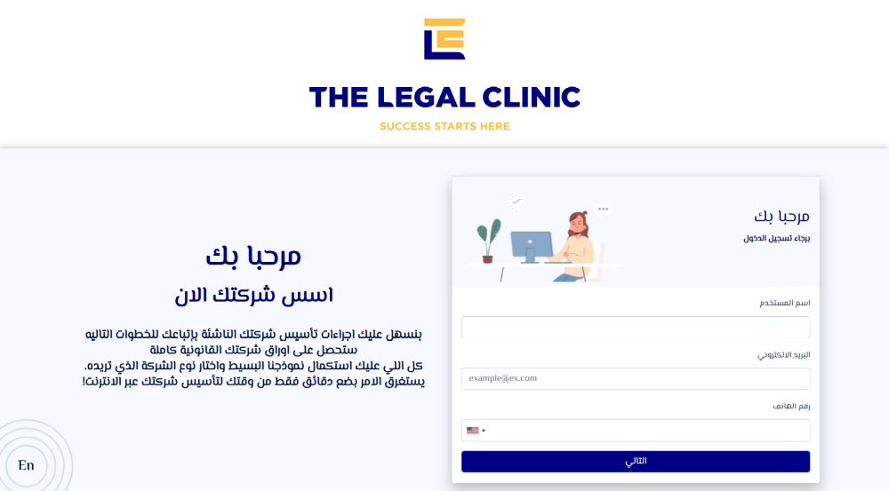

1 | 2 | 3 | 4 | 5
Company type | Company data | Shareholders data | Management data | Final date

Corporations | Partnerships
A Corporation enjoys a legal entity separated from its owners.
Each shareholder has a limited liability – limited to the amount of shares he owns in the company’s capital
 | Limited Liability Company (LLC)  LLC is the least complicated and the most recommended to Start-ups.  It is a company with a minimum of (2) shareholders whether Egyptians or foreigners, and whether natural persons or Juridical persons (companies).  The liability of the shareholders is limited to their shares. There is no required minimum capital for LLC. | Required Documents
Egyptian Joint Stock Company (JSC)
JSC is a company with a minimum of (3) shareholders whether Egyptians or foreigners, and whether natural persons or juridical persons (companies).
The shareholders’ liability is limited to their shares in the company’s capital.
The required minimum capital is 250 thousand Egyptian Pounds.
10% shall be paid to incorporate, 25% shall be paid within the first (3) months after incorporation, and 100% shall be paid within (5) years. All amounts must be deposited at one of the commercial banks.
JSC is managed though a Board of Directors, which must be consisted of a minimum of 3 members regardless of their nationalities.
One Person Company
It is a company with only one owner, whether Egyptians or foreigners, and whether natural persons or juridical persons (companies).

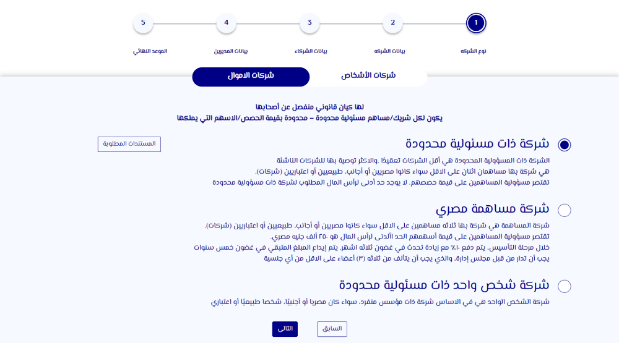
1 | 2 | 3 | 4 | 5
Company type | Company data | Shareholders data | Management data | Final date

Suggest a name for your company
1st Suggestion | 2nd Suggestion | Add suggestions
Basic Data
Company’s Activity | Company’s Address
Capital | Share value

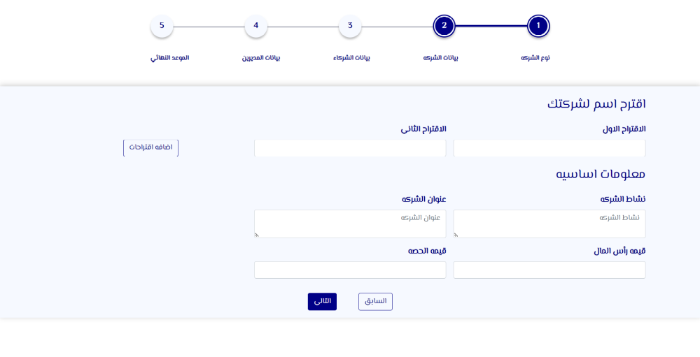

1 | 2 | 3 | 4 | 5
Company type | Company data | Shareholders data | Management data | Final date

Number of Shareholders

Next Previous

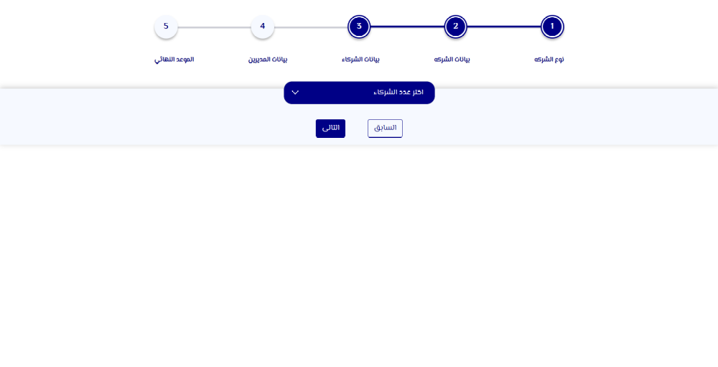

1 | 2 | 3 | 4 | 5
Company type | Company data | Shareholders data | Management data | Final date

 | 2
Shareholder’s Name | Shareholder’s Nationality | Percentage of shares in the capital
Add National ID |  | Remove Shareholder

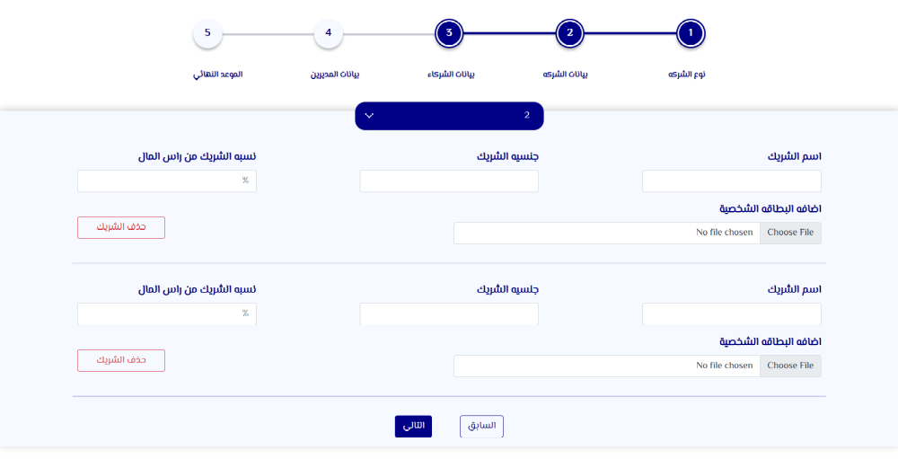

1 | 2 | 3 | 4 | 5
Company type | Company data | Shareholders data | Management data | Final date

Add Managers Names
Add

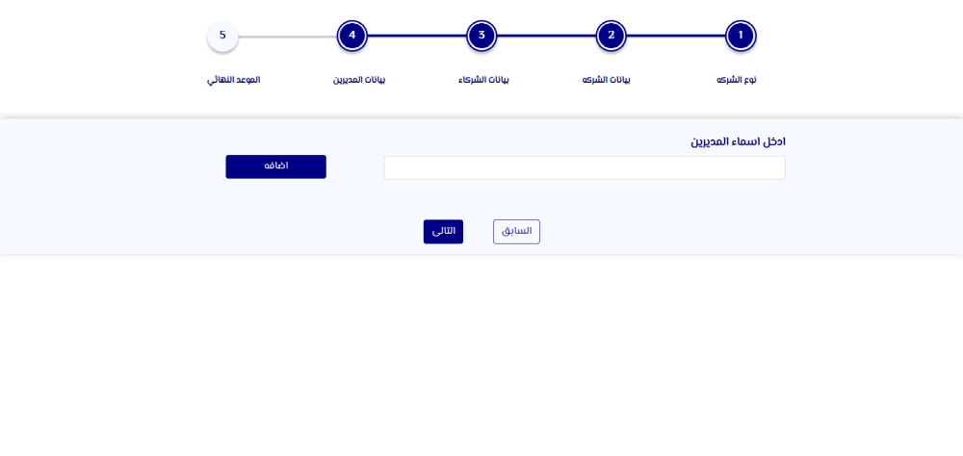

1 | 2 | 3 | 4 | 5
Company type | Company data | Shareholders data | Management data | Final date

Add Managers Names
Add

Manager’s name
Manager’s nationality
Powers:
Signing before banks, opening bank accounts and operate on the company’s account.
Signing contracts on behalf of the company
Appear on behalf of the company before the governmental entities.

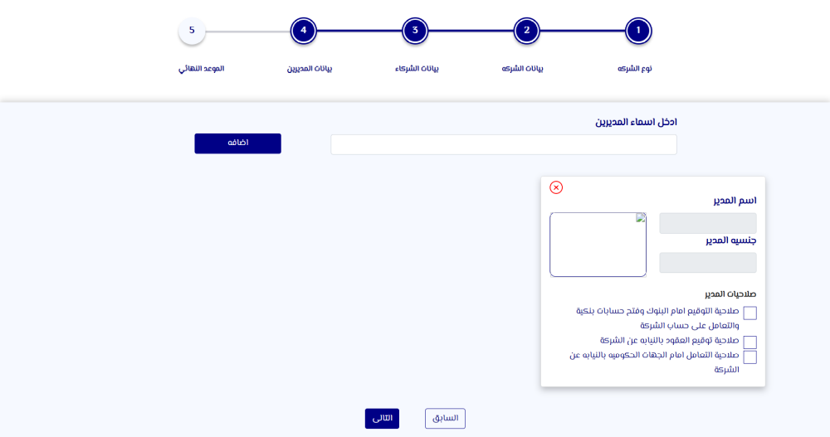

1 | 2 | 3 | 4 | 5
Company type | Company data | Shareholders data | Management data | Final date

Download Power of Attorney and fill in the data

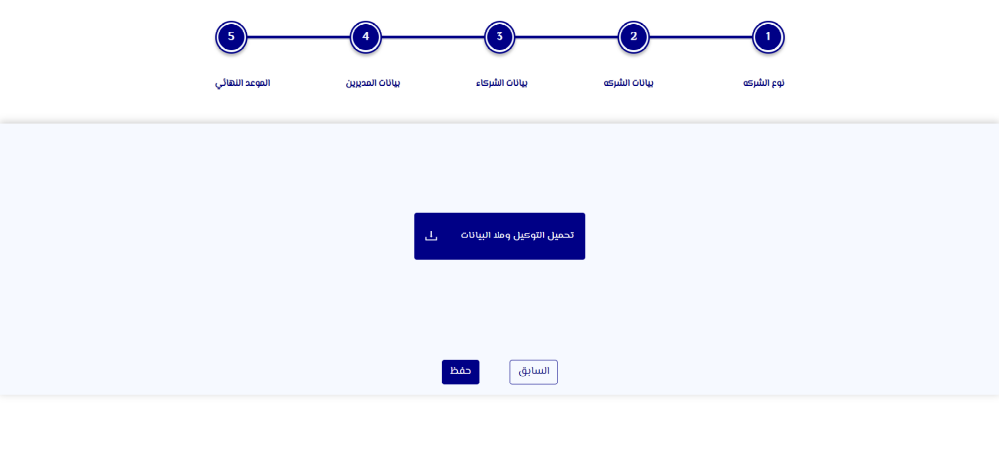

1 | 2 | 3 | 4 | 5
Company type | Company data | Shareholders data | Management data | Final date

Suggest a name for your company
1st Suggestion | 2nd Suggestion | Add suggestions
Basic Data
Company’s Activity | Company’s Address
Capital  Minimum of 250 thousand EGP | Share value

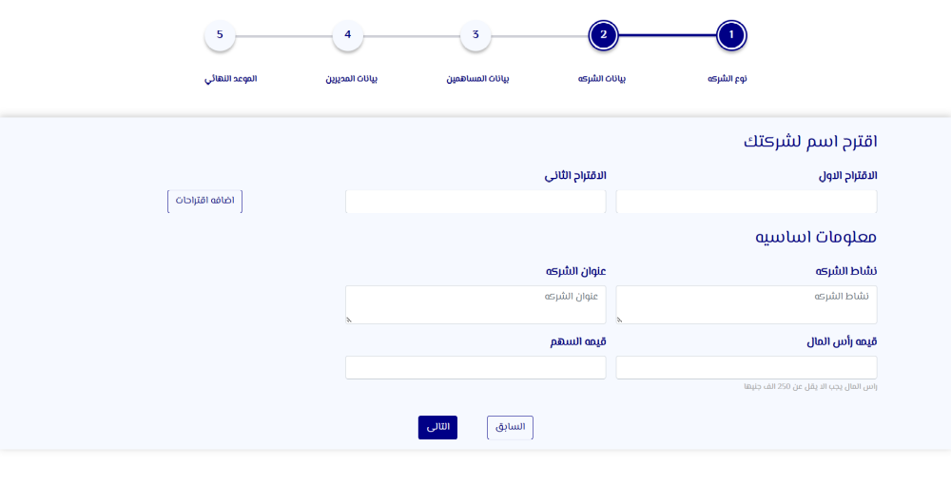

1 | 2 | 3 | 4 | 5
Company type | Company data | Shareholders data | Management data | Final date

Number of Shareholders

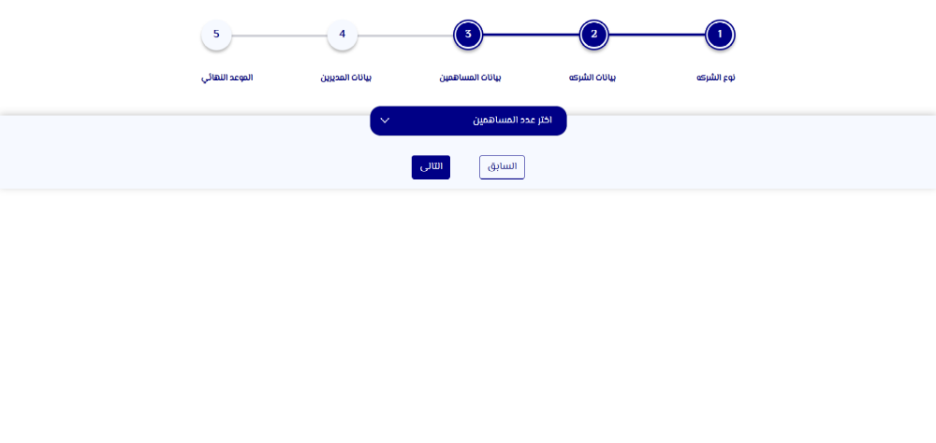

1 | 2 | 3 | 4 | 5
Company type | Company data | Shareholders data | Management data | Final date

Add Board Members Names
Add

Please select the position
Member’s name
Manager’s nationality
Powers:
Signing before banks, opening bank accounts and operate on the company’s account.
Signing contracts on behalf of the company
Appear on behalf of the company before the governmental entities.

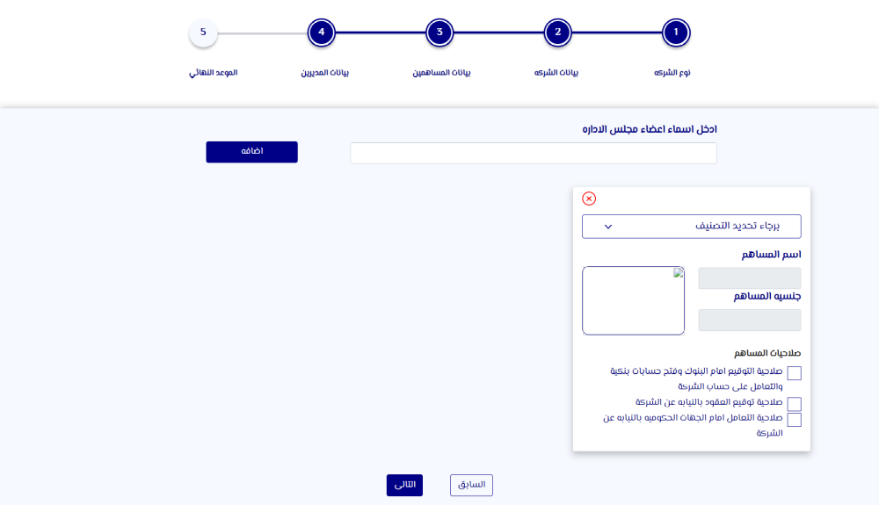
1 | 2 | 3 | 4 | 5
Company type | Company data | Shareholders data | Management data | Final date

Owner’s Data
Owner’s Name | Owner’s Nationality
Add National ID | Remove owner

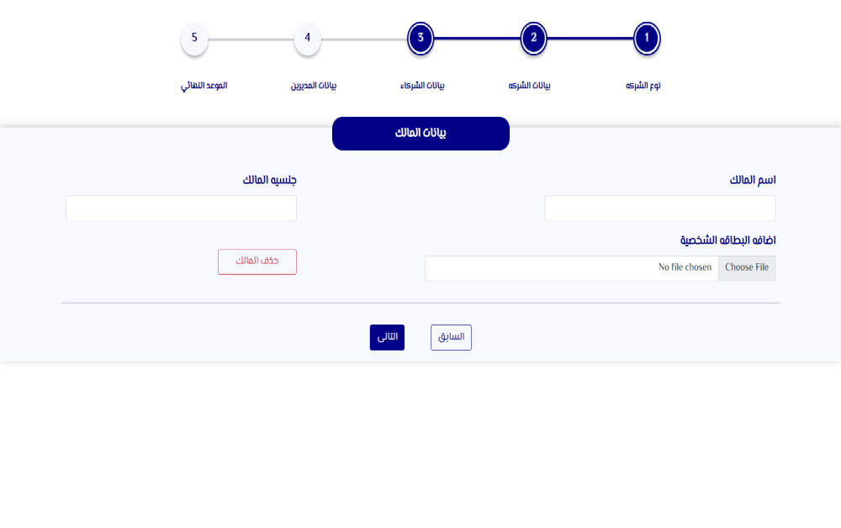

1 | 2 | 3 | 4 | 5
Company type | Company data | Shareholders data | Management data | Final date

Corporations | Partnerships

Partnerships do not enjoy a separate legal entity from their owner. Each partner enjoys an unlimited liability along with a personal liability in all debts incurred by the partnership. A partner cannot transfer his share without the prior consent of the other partners.
Sole Proprietorship
It is owned by one person “natural” and it is named after its owner.
It is not possible for other partners to join the sole proprietorship.
The owner is responsible of managing the project in full and the liability is unlimited.
Note: Sole Proprietorship cannot be transferred to any other type of companies.
General Partnership
It consists of a minimum of two partners, they enjoy the capacity of merchant.
It is named after its partners followed by the word partners or CO and its name shall be named after a real partner’s name in the partnership.
The partners’ liability is unlimited and joint.
Limited Partnership
It consists of a minimum of (2) partners.
The partners are divided into (2) types:
1- General Partner (Enjoys the capacity of a merchant)
The partnership is name after one or more of its general partners, followed by the word “Partners” or “CO” and the name must be real.
General Partners have unlimited and personal liability.
2- Limited Partner
Limited Partners do not have the right to manage the partnership. Their liability is limited to their shares in the partnership capital.

Registration is successful
You are being transferred to Digital Egypt to reserve a date.
